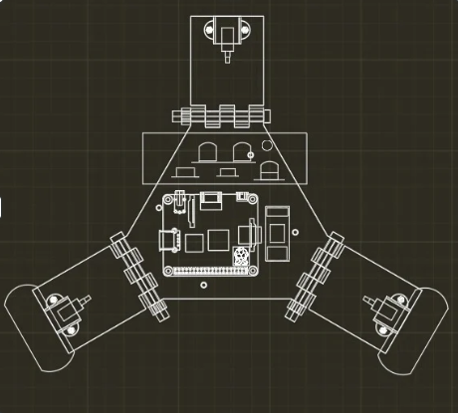

# TOP VIEW

The novelty resides in the shape and configuration of the **“HAZARDSCOUT: MULTIPURPOSE EMERGENCY RESPONSE ROBOT”** as illustrated

No claim is made by virtue of this registration in respect of any mechanical or other action of any mechanism whatever or in respect of any mode or principle of construction of the Article

No claim is made by virtue of this registration to any right to the exclusive use of the words, letters, numbers, Color, or trademarks appearing in the representation.

## Dated: 08 MAY 2025 Sign, (Applicant)

Shah Shashwat Nimesh Shah Kruti Bhavesh Gupta Manasvi Ganesh

Jobanputra Khushi Dharmendra

Karani Ruhina

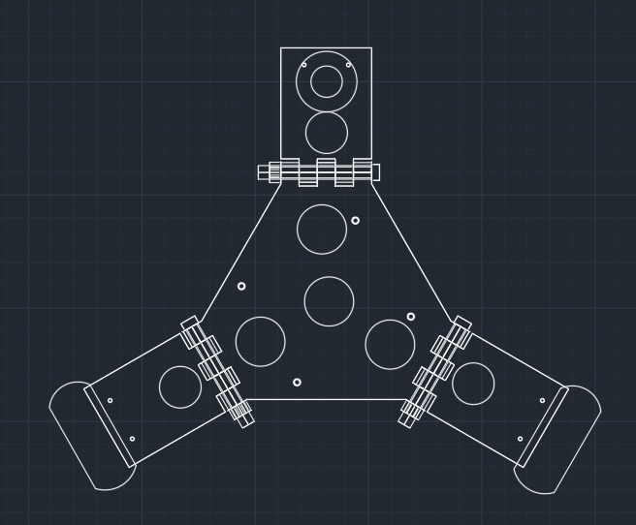

# BOTTOM VIEW

The novelty resides in the shape and configuration of the **“HAZARDSCOUT: MULTIPURPOSE EMERGENCY RESPONSE ROBOT”** as illustrated

No claim is made by virtue of this registration in respect of any mechanical or other action of any mechanism whatever or in respect of any mode or principle of construction of the Article

No claim is made by virtue of this registration to any right to the exclusive use of the words, letters, numbers, Color, or trademarks appearing in the representation.

## Dated: 08 MAY 2025 Sign, (Applicant)

Shah Shashwat Nimesh Shah Kruti Bhavesh Gupta Manasvi Ganesh

Jobanputra Khushi Dharmendra

Karani Ruhina

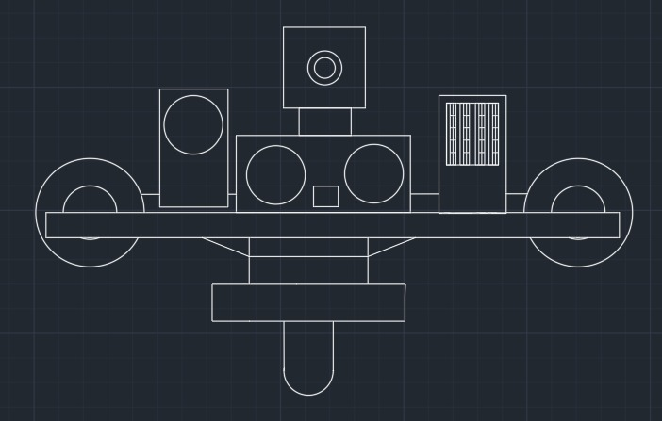

# FRONT VIEW

The novelty resides in the shape and configuration of the **“HAZARDSCOUT: MULTIPURPOSE EMERGENCY RESPONSE ROBOT”** as illustrated

No claim is made by virtue of this registration in respect of any mechanical or other action of any mechanism whatever or in respect of any mode or principle of construction of the Article

No claim is made by virtue of this registration to any right to the exclusive use of the words, letters, numbers, Color, or trademarks appearing in the representation.

## Dated: 08 MAY 2025 Sign, (Applicant)

Shah Shashwat Nimesh Shah Kruti Bhavesh Gupta Manasvi Ganesh

Jobanputra Khushi Dharmendra

Karani Ruhina

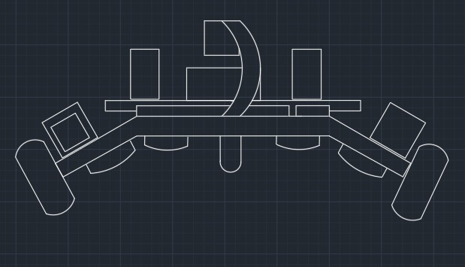

# REAR VIEW

The novelty resides in the shape and configuration of the **“HAZARDSCOUT: MULTIPURPOSE EMERGENCY RESPONSE ROBOT”** as illustrated

No claim is made by virtue of this registration in respect of any mechanical or other action of any mechanism whatever or in respect of any mode or principle of construction of the Article

No claim is made by virtue of this registration to any right to the exclusive use of the words, letters, numbers, Color, or trademarks appearing in the representation.

## Dated: 08 MAY 2025 Sign, (Applicant)

Shah Shashwat Nimesh Shah Kruti Bhavesh Gupta Manasvi Ganesh

Jobanputra Khushi Dharmendra

Karani Ruhina

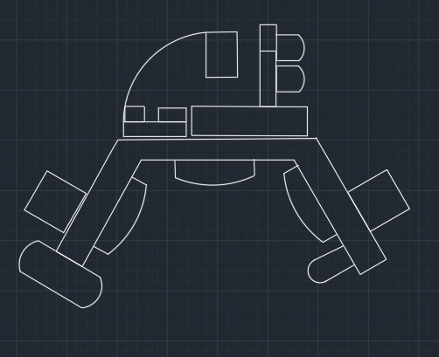

# LEFT VIEW

The novelty resides in the shape and configuration of the **“HAZARDSCOUT: MULTIPURPOSE EMERGENCY RESPONSE ROBOT”** as illustrated

No claim is made by virtue of this registration in respect of any mechanical or other action of any mechanism whatever or in respect of any mode or principle of construction of the Article

No claim is made by virtue of this registration to any right to the exclusive use of the words, letters, numbers, Color, or trademarks appearing in the representation.

## Dated: 08 MAY 2025 Sign, (Applicant)

Shah Shashwat Nimesh Shah Kruti Bhavesh Gupta Manasvi Ganesh

Jobanputra Khushi Dharmendra

Karani Ruhina

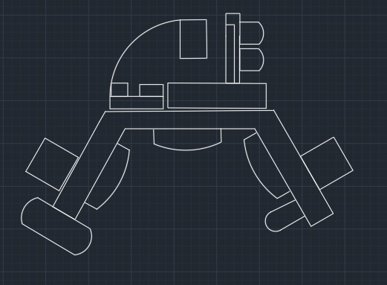

# RIGHT VIEW

The novelty resides in the shape and configuration of the **“HAZARDSCOUT: MULTIPURPOSE EMERGENCY RESPONSE ROBOT”** as illustrated

No claim is made by virtue of this registration in respect of any mechanical or other action of any mechanism whatever or in respect of any mode or principle of construction of the Article

No claim is made by virtue of this registration to any right to the exclusive use of the words, letters, numbers, Color, or trademarks appearing in the representation.

## Dated: 08 MAY 2025 Sign, (Applicant)

Shah Shashwat Nimesh Shah Kruti Bhavesh Gupta Manasvi Ganesh

Jobanputra Khushi Dharmendra

Karani Ruhina